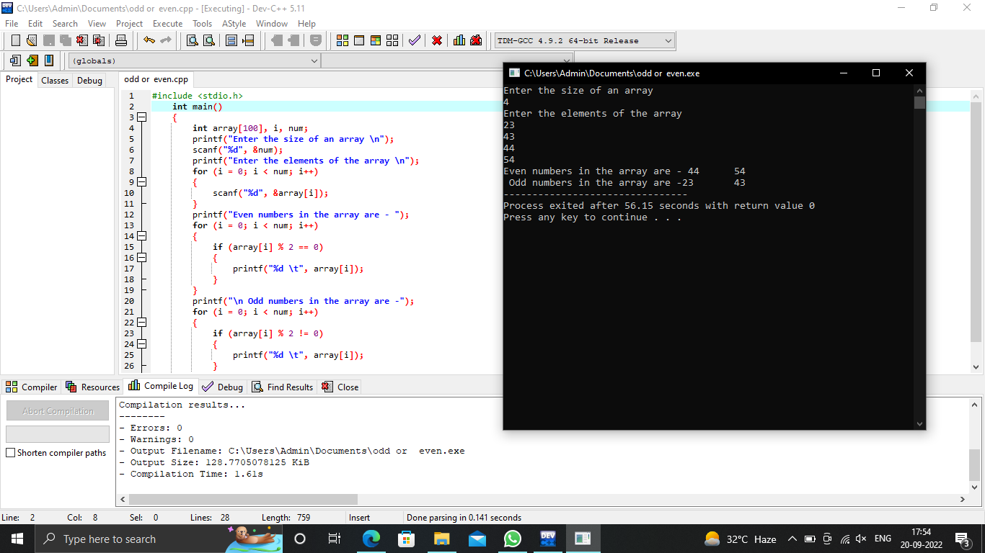

#include <stdio.h>

int main()

{

int array[100], i, num;

printf("Enter the size of an array \n");

scanf("%d", &num);

printf("Enter the elements of the array \n");

for (i = 0; i < num; i++)

{

scanf("%d", &array[i]);

}

printf("Even numbers in the array are - ");

for (i = 0; i < num; i++)

{

if (array[i] % 2 == 0)

{

printf("%d \t", array[i]);

}

}

printf("\n Odd numbers in the array are -");

for (i = 0; i < num; i++)

{

if (array[i] % 2 != 0)

{

printf("%d \t", array[i]);

}

}

}